Good Faith Estimate for Health Care Items and Services

**PATIENT**

Patient First Name Middle Name Last Name

Patient Date of Birth: **_______________**/**________________**/**________________**

Patient Identification Number:

**Patient Mailing Address, Phone Number, and Email Address**

Street or PO Box Apartment

City State ZIP Code

Phone

Email Address

Patient’s Contact Preference: ( ) By Mail ( ) By Email

**Patient Diagnosis**

Primary Service or Item Requested/Scheduled

Patient Primary Diagnosis Primary Diagnosis Code

Patient Secondary Diagnosis Secondary Diagnosis Code

1

Page 2

If scheduled, list the date(s) the Primary Service or Item will be provided:

( ) Check this box if this service or item is not yet scheduled

**Total Estimated Cost: $ ____________________**

Provider Name: _________________________ Estimated Total Cost: ________________

Provider Name: _________________________ Estimated Total Cost: ________________

Provider Name: _________________________ Estimated Total Cost: ________________

Date of Good Faith Estimate: **_______________**/**________________**/**________________**

The following is a detailed list of expected charges for (__________________________),

LIST PRIMARY SERVICE OR ITEM

Scheduled for (_________________________). (If items or services are reoccurring, “The

LIST DATE OF SERCICE, IF SCHEDULED

Estimated costs are valid for 12 months from the date of the Good Faith Estimatee.”)

Page 3

DANIELS MEMORIAL HEALTHCARE CENTER 1 (Estimate)

National Provider Identifier Taxpayer Identification Number

______________________________ 81-6016920

Contact Person Phone Email

__________________________________ (406) 487-2296 ______________________

City State ZIP Code

Scobey Montana 59263

Street Address

105 5th Ave. E.

Provider/Facility Name Provider/Facility Type

**Detail of Services and Items for (Provider/Facility 1)**

Expected Cost

Quantity

Service Code

Type: CPT/CDM

Diagnosis Code

(ICD code)

Service Item

Address (street,city,state,ZIP)

(where service/item will be provided)

**Additional Health Care Procider/Facility Notes**

**Total Expected Charges From (Provider/Facility 1) $**



Page 4

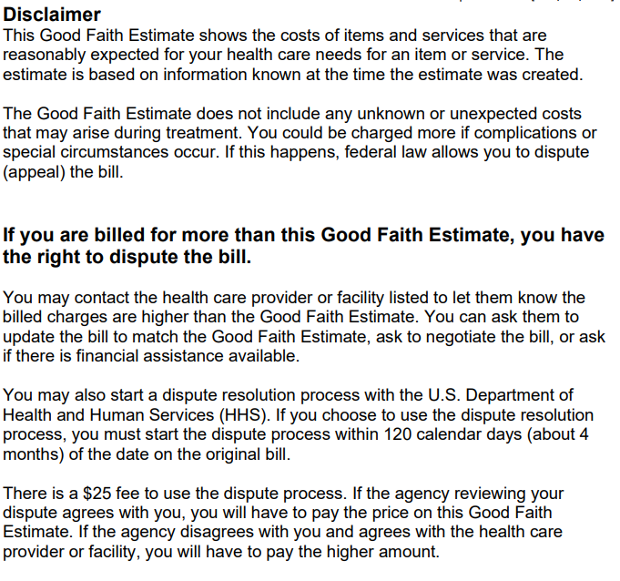

To learn more and get a form to start the process, go to

[www.cms.gov/nosurprises or call 1-800-985-3059](http://www.cms.gov/nosurprises%20%20or%20call%201-800-985-3059).

For questions or more information about your right to a Good Faith Estimate or the dispute process, visit [www.cms.gov/nosurprises](http://www.cms.gov/nosurprises) or call 1-800-985-3059.

